Put the title of the paper here with font Bold Arial,
size 14pt, centered, length up to 2 lines

First + Middle (initial) + Last name∗1a(Superscript―∗:Corresponding, ¹:affiliation, ª:footnote info),
Sullivan T. Smith^{∗2}, Tanaka Ikarashi^{1a} and Ahmed M. Mohamed^{2b} 11pt

¹Affiliation (Department, Institute, Address, Country) with font Arial, size 8 pt
²School of Computing and Engineering, Building Performance and Climate Change Research Group, St Mary Road, Ealing, London, W5 5RF

(Received keep as blank , Revised keep as blank , Accepted keep as blank )9pt

Abstract. This study aimed to develop a model to accurately predict the acceleration of structural systems during an earthquake. The acceleration and applied force of a structure were measured at current time step and the velocity and displacement were estimated through linear integration.……10 pt

Keywords: complex terrain; typhoon wind field; CFD simulation; surface roughness length; topography 10 pt

This is an open access article distributed under the Creative Commons Attribution License which permits unrestricted use, distribution, and reproduction in any medium, provided the original work is properly cited.

1. Introduction 10pt

The growing awareness of the need to minimise greenhouse gas (GHG) and mitigate climate change has resulted in a greater focus on the embodied carbon (EC) of construction material. Many investigations about reduction of carbon emissions within built environment have been carried out. Blay-Armah et al. (2022) have studied the reduction strategies for buildings’ end of life using circular economy (CE) principles. A general sustainable carbon reduction method has been described by B-Jahromi and B-Armah (2022) ……10pt

2. Section title: Level 1

The system examined, shown schematically in Fig. 1 is a whole life cycle of a building. The building has a total gross area of 280m². The publications (Mohebbi et al. 2021; Hasan and B-Jahromi, 2020; Gibson and Orr, 2022; Akbarnezhad and Xiao, 2017) are considered also with material selection impacts on carbon emission reduction are investigated. Carbon reduction investigations in buildings concentrating on material selection with characteristics of building components have been studied using mathematical models and the finite element method (Hassan and B-Jahromi, 2020; Blay-Armah et al., 2022). ……

2.1 Numerical simulation procedure

The calculation of embodied carbon emissions of each material of the life cycle can be determined by equation (1):
$${EC}_{i}=∑i\left(Qmat,i x ECFi\right)$$ | (1)
Life-cycle assessment (LCA) is a modern tool used to assess the environmental effects of a product throughout its life span - from raw materials extraction to final disposal. It is a systematic and holistic methodological technique to assess the environmental burdens of a product or a process. the building elements and individual materials are displayed in Tables 1-2.……

3. Section title: Level 1

To quantify the operational carbon emissions, the construction materials were assigned to the build elements. The thermophysical characteristics of the building materials, specifically walls, frames, floor, and doors were defined to generate the BRUK-L report.

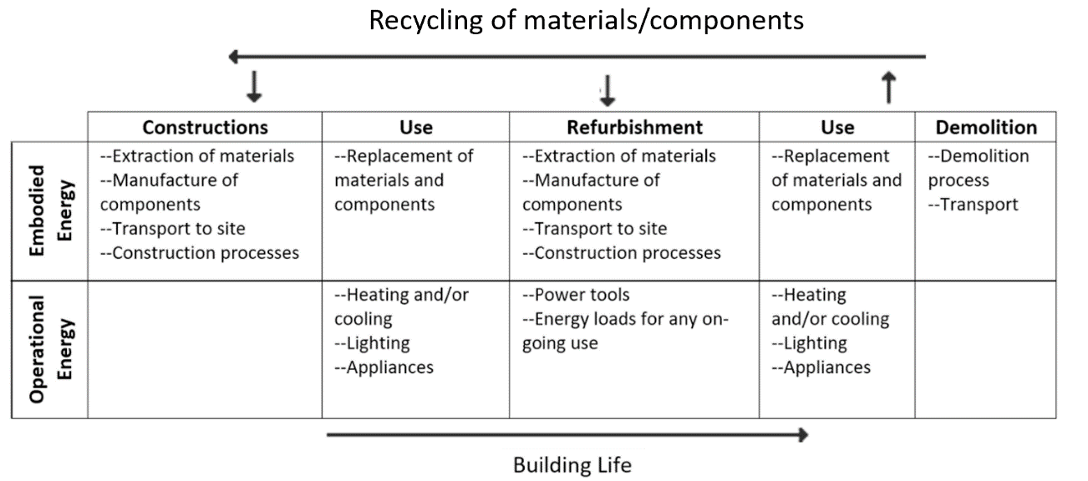
Fig. 1 An illustrative building whole life cycle 10pt

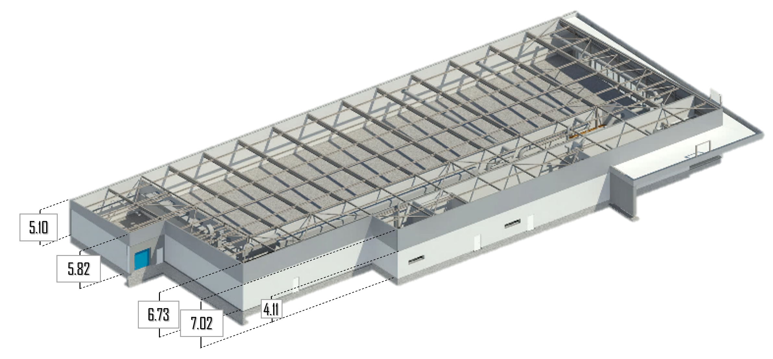 | 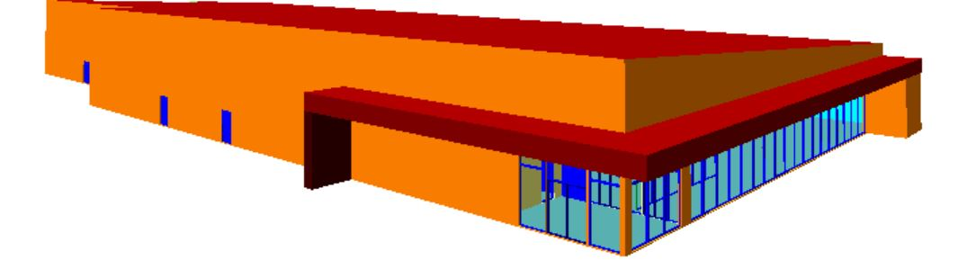
(a) Simulated building by Autodesk® Revit® BIM software | (b) Simulated building Thermal Analysis software (TAS)
Fig. 2 3D models for calculating whole life cycle carbon emissions. The two mix designs were different, but had similar objective

Table 1 Caption 10pt
Building Element |  | Structural element and component
Substructure | Foundation including foundation wall and floor slab
Superstructure | Structural frame: roof beams, columns and tie beams
 | Roof: steel profile system on tapered insulation

Table 2 Caption
Material | Weight (kg) | Embodied Carbon (kgCO2e)
Aluminium | 117 | 2,670
Concrete | 1,055 | 444
Steel | 2,832 | 2,312
Timber | 1,269 | 21

4. Section title: Level 1

4.1 Subtitle: Level 2

4.1.1 Subtitle: Level 3
The embodied carbon of each material was calculated within the parameters (Fig 1). The results obtained from the preliminary carbon emission analysis are shown in Table 2.
The results show that……

Subtitle: Level 4
The results obtained from the preliminary analysis of carbon emission show that the timber contributed the least carbon emissions during the end of life with the total emission of 21 (kgCO2e). The findings of the current study support the previous studies which have suggested that the use of wood results in lower average carbon emission. For instance, Hafner and Schäfer (2018) concluded that timber-based materials can potentially reduce carbon emissions by 9–56% when compared to mineral substitutes. Similar conclusions were made in a study for the UK’s Committee on Climate Change by Spear et al. (2019) which observed that substituting masonry with timber frames can achieve

nearly 20% reduction in embodied carbon emissions.….

5. Conclusions

The aim of this research was to examine carbon emission reduction in construction materials. The life cycle phases included in the analysis were production, construction, operation, and disposal. A case study of a commercial building LCA was performed to evaluate the emissions by individual building materials. A mathematical simulation procedure for predicting reduction was developed.
The reduction of carbon emission depends heavily on the construction material used and construction method……….

Acknowledgments

The research described in this paper was financially supported by the Natural Science Foundation ……

References

Author(s) (Year), “Title of paper (Capital letter only for the first letter)”, Name of Journal (Italic), Volume number in bold(Issue number in non-bold), page-page. doi address. 9pt
Akbarnezhad, A. and Xiao, J (2017), “A comparison of large……”, Buildings, 91(4), 1301-1328. https://doi.org/10.12989/sem.2011.91.4.1301.
Blay-Armah, A. Bahadori-Jahromi, A. Mylona, A. Ferri, M. and Barthope, M. (2022), “A comparison of large……”, Sustainability, 91(4), 1301-1328. https://doi.org/10.12989/sem.2011.91.4.1301.
B-Jahromi, A. and B-Armah, A. (2022), “A comparison of large……”, Enviro. Sci, 91(4), 1301-1328. https://doi.org/10.12989/cac.2012.91.4.1301.
Cheng, Y.F. and Xu, B.M. (2013a), “A comparison of large……”, Steel Comp. Struct., 91(4), 1301-1328. https://doi.org/10.12989/scs.2013.91.4.1301.
Cheng, Y.F. and Xu, B.M. (2013b), “A comparison of large……”, J. Wing Eng., 91(4), 1301-1328. https://doi.org/10.12989/xxx.2013.91.4.1301.
Author(s) (Year), Name of Book (Every word starts in capital letter), Name of publishing company, City, State, Country.
Harris, D.C. (2007), Quantitative Chemical Analysis, W.H. Freeman and Company, New York, NY, USA.
Harris, D.C. (2007), Quantitative Chemical Analysis, (7th Edition), W.H. Freeman and Company, New York, NY, USA.
Author(s) (Year), “Title of paper”, Name of Proceeding or Name of occasion (Every word starts in capital letter), City, Month.
Kerciku, A.A., Bhattacharya, S., Burd, H.J. and Lubkowski, Z.A. (2008), “Fixity of pile foundations ……”, Proceedings of the 14th World Conference on Earthquake Engineering, Bejing, China, October.
Author(s) (Year), “Title of paper”, Ph.D. Dissertation, Name of University, City.
Sajjad, M. (2005), “Evaluation of bacterial strategies……”, Ph.D. Dissertation, Michigan State University, Michigan.
Author(s) (Year), Title of Paper (Every word starts in capital letter), Name of Magazine, Published Month.
Carey, A.A. and Hayzen, A.J (2001), The Dielectric Constant and Oil Analysis, Practicing Oil Analysis Magazine, September.
Author(s) (Year), “Research Report Title as appears on the cover page”, Research Report Number; Name of University/Institution.
Wu, Y.F., Oehlers, D.J. and Griffith, M.C. (2001a), “Numerical simulation of composite plated columns”, Research Report No. R172; Department of Civil and Environmental Engineering, Adelaide University, Adelaide, Australia.
Gourley, B.C., Tort, C., Denavit, M.D., Schiller, P.H. and Hajjar, J.F. (2008), “A synopsis of studies of the monotonic and cyclic behavior of concrete-filled steel tube members, connections and frames”, Report No. NSEL-008; Newmark Structural Engineering Laboratory, Department of Civil and Environmental Engineering, University of Illinois at Urbana-Champaign, Champaign, IL, USA.
Design code (Year), Title, Full name of the code, Name of Organization; City, Country.
ACI 318 (2011), Building code requirements for structural concrete and commentary, American Concrete Institute; Farmington Hills, MI, USA.
Eurocode (2003), Design of Steel Structures. Part 1.5: Plated Structural elements, European Committee for Standardization; Brussels, Belgium.
Name of URL (Year), Title of the website link; Name of Organization, City, Country. Link address
ARTeMIS (2004), Ambient Response Testing and Modal Identification Software ARTeMIS Extractor Pro 3.43.; Structural Vibration Solution A/S Aalborg East, Denmark. www.svibs.com
COMSOL Inc. (2013), http://www.comsol.com

∗Corresponding author, Ph.D. Professor (or Ph.D., etc.), 10pt E-mail: email address ªPh.D. ^{b}Ph.D. Student

